Integration of IBM Node-Red with AWS IoT Console

|  |  |
| --- | --- |
| Title | Integration of IBM Node-Red with AWS IoT Console |
| By | Meenakshi Murugappan |
| Student Id: | L00156569 |

# Summary

This document describes the implementation of the MQTT broker using IBM Node-Red and publishes the message to AWS IoT Console

It describes the following tasks:

1. Installing the Node-Red application on the IBM Cloud account.
2. Creating the AWS IoT Policy
3. Attaching the certificate to IoT Policy
4. Update the setting to the TLS 1.2 certificate in the Node-Red cloud app.
5. Publish the message from IBM Node-Red app to the AWS IoT console.
6. Subscribe and test the topic using the MQTT client in AWS IoT console to consume the MQTT message published by IBM Node-Red app.

Contents

Summary 1

Resources and Prerequisites 3

Introduction 3

Steps 4

Problems Faced 9

Summary 9

References 9

# Resources and Prerequisites

1. Valid AWS credentials to sign in to the AWS console to access the IoT core services
2. Valid IBM cloud account to install the node-red app.

# Introduction

This document provides the instruction to integrate the IBM Node-Red [[1]](https://nodered.org/) and publish the message to the AWS IoT console. To publish the message to AWS IoT console, as all Amazon web services should have security consideration 1) Policy to do the operation in AWS IoT services and 2) Attach the certificate to the policy and 3) Upload the TLS 1.2 certificate in any device to connect to AWS IoT core services [[2]](https://aws.amazon.com/iot-core/). Connecting devices to AWS IoT cloud is the first step in the project for Integrating the AWS with industrial devices. The below diagram depicts the example for an SME of the cold storage industry and the devices connected to AWS IoT core services using the MQTT broker. For the scope of the project MQQT out options in the IBM Node-Red app which act as a virtual device.

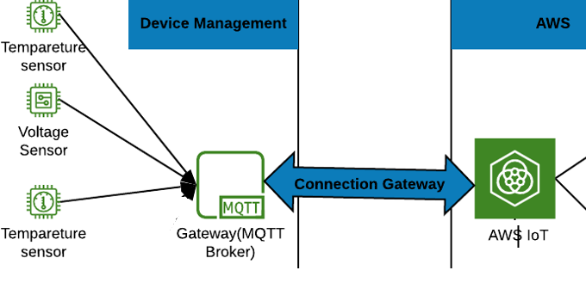

**Figure 1: Integrating IBM Node-Red app with AWS IoT services for Cold Storage SME project**

# Steps

1. Log in to the IBM cloud and search for Node-Red [[4]](https://nodered.org/docs/platforms/bluemix) to install the same.

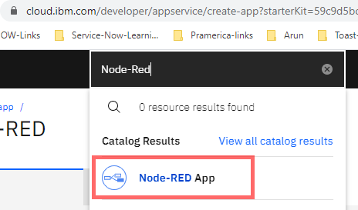

1. Please follow the instructions in the link [[5]](https://developer.ibm.com/components/node-red/tutorials/how-to-create-a-node-red-starter-application/) to install the Node-Red App, masked the URL in the below images to act as virtual devices, the installed app will look like this as shown below.

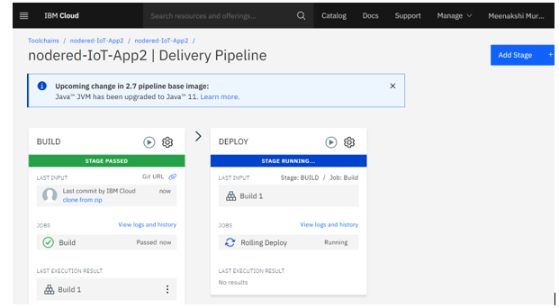 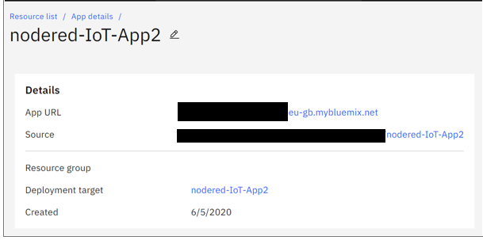

1. Click the create policy “NoderedIoTPolicy” on the left navigation of the AWS IoT secure to create a policy. Please refer to the link [[3]](https://docs.aws.amazon.com/iot/latest/developerguide/iot-policies.html?icmpid=docs_iot_console) for more details on policy action.

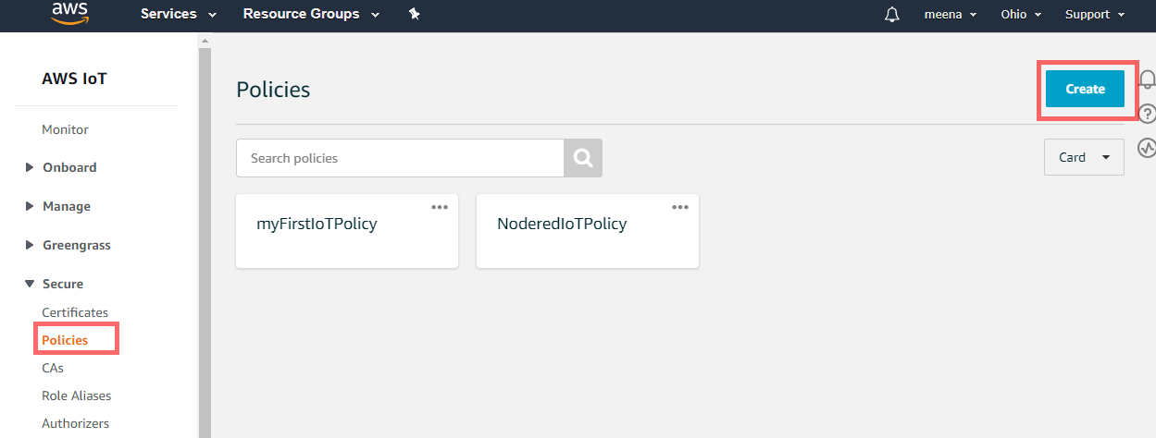

1. Attached a statement to the policy to allow IoT action, for this exercise we allowed IoT operations by IoT:*.

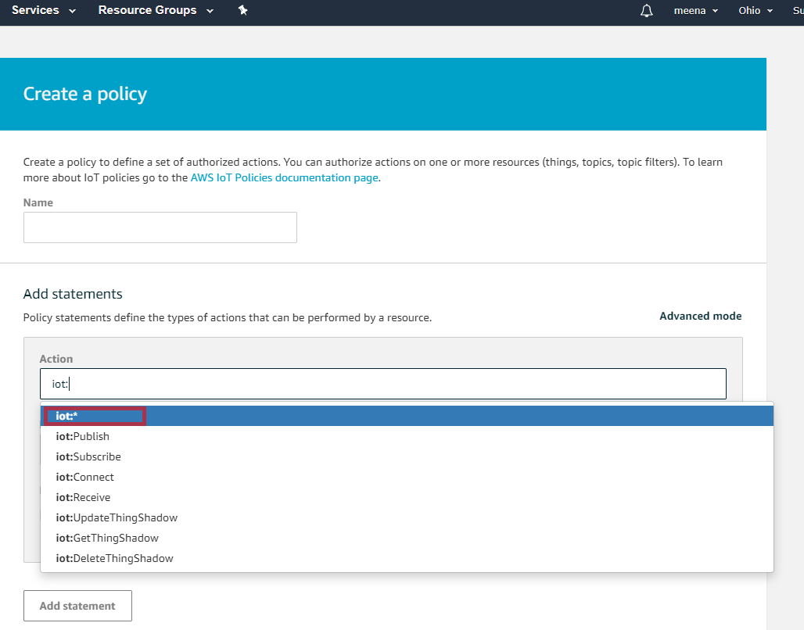

1. The above created in policy is available as JSON format, attached the same in the git hub project in the JSON folder and ensure the Allow statement has been selected while creating the AWS.

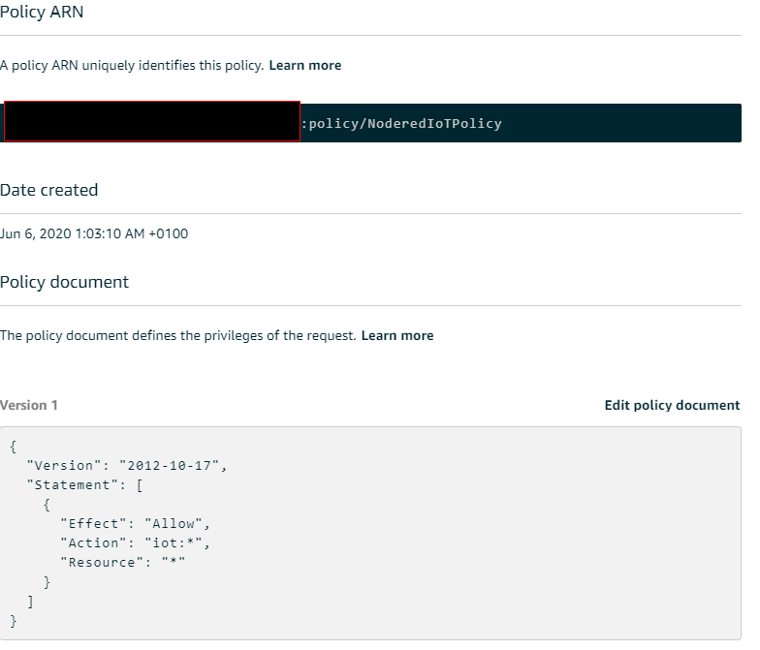

1. To publish the message from devices policy has been created in the above step and create a certificate as shown below to generate a certificate, public key, and private key using AWS IoT's certificate authority. Downloaded the public certificate and a key to attach in the IBM Node-Red application in Bluemix cloud.

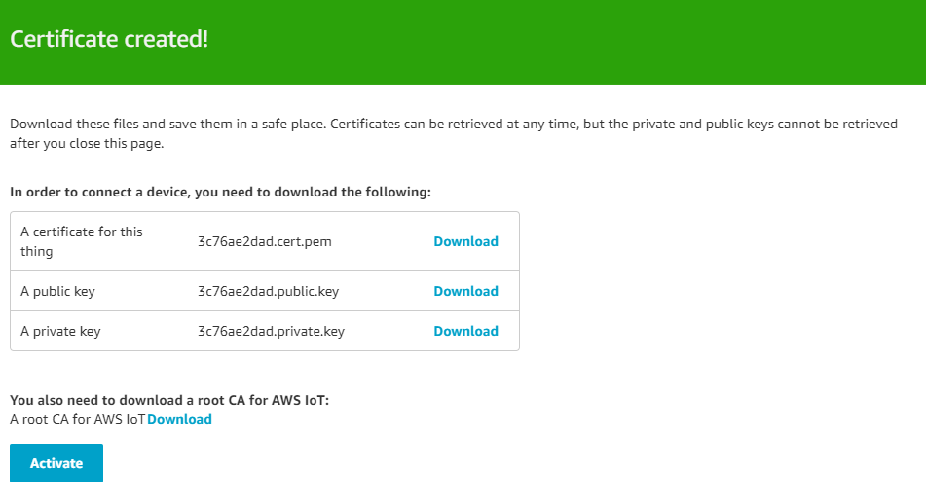

1. Download the root CA certificate from the link [[4]](https://docs.aws.amazon.com/iot/latest/developerguide/server-authentication.html?icmpid=docs_iot_console#server-authentication-certs) as shown in the below figure.

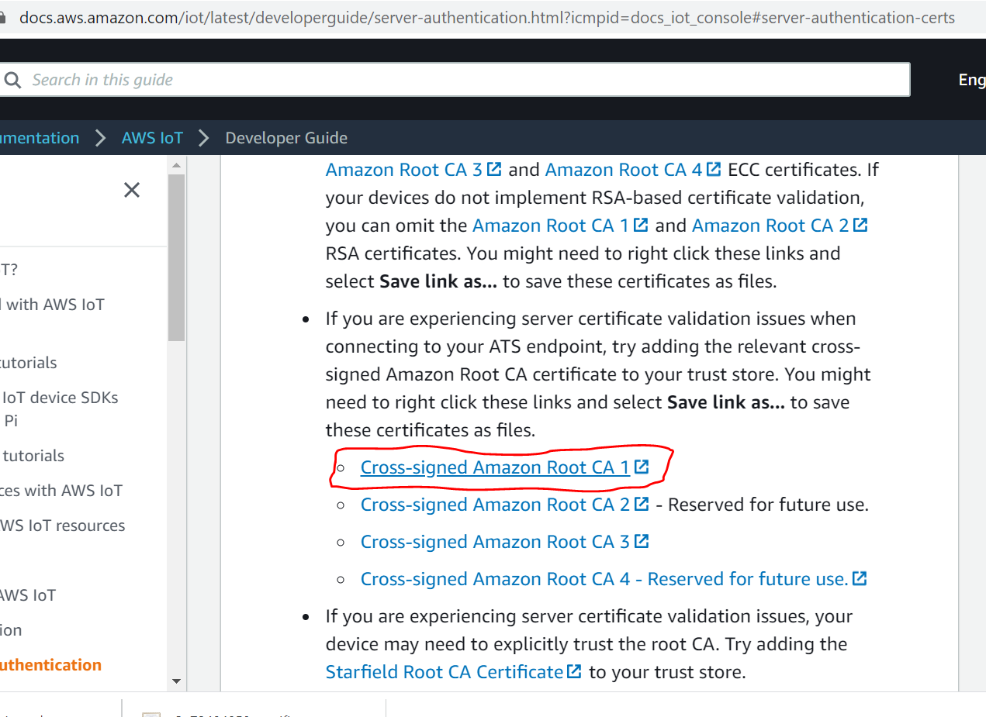 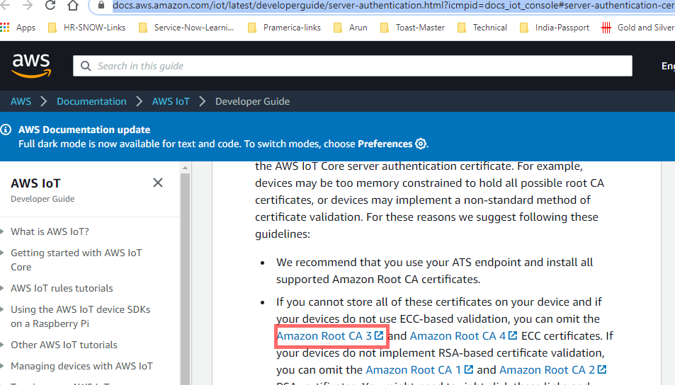

1. Once the certificate is created, attach to the “NoderedIoTPolicy” IoT policy created in step 5.
2. All the certificates downloaded to the system and attached to the git hub in the certificates folder used for this project. The certificates created are shown in the below image.

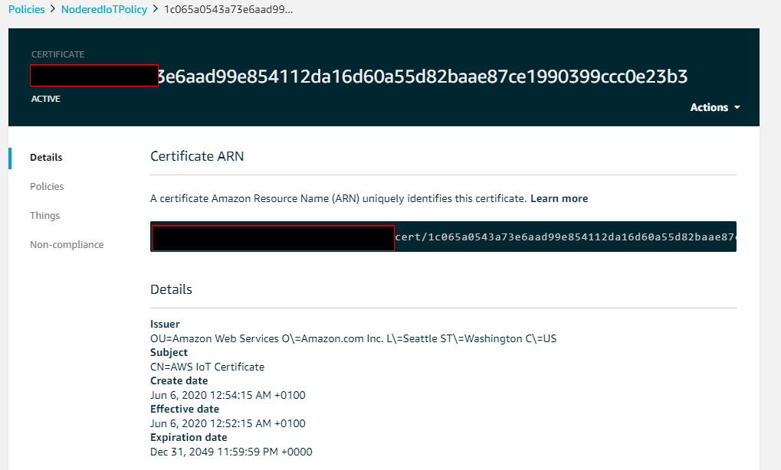

1. Understood the concept of IBM Node, by playing within and out methods, Timestamp and URL can be used to publish the MQTT message for the Http input method as shown in the image below.

.

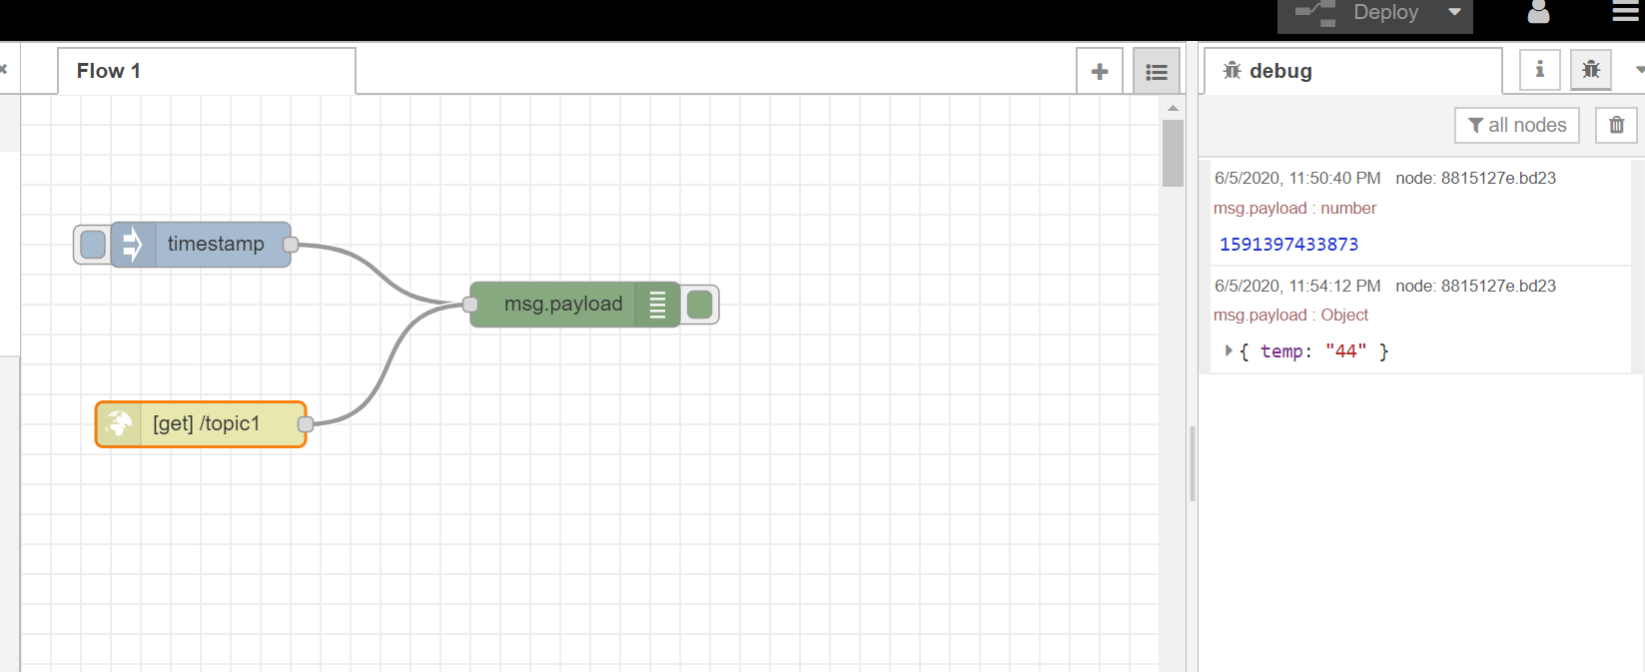



Debug Input in green color can be used to test the message as shown on the left side of the below image

1. To connect AWS IoT from IBM Node-Red, “MQTT out” method is used, this is the method that will act as a virtual voltage sensor for the cold storage SME project.

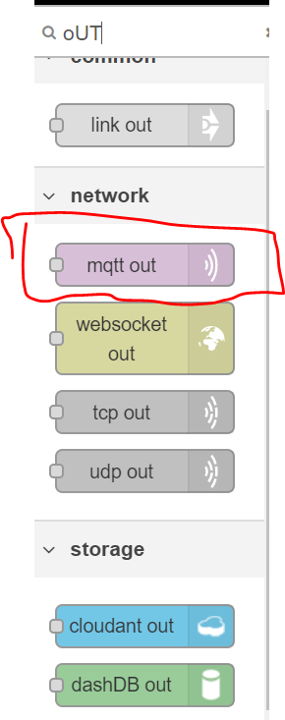

1. Edit the settings of the MQQT OUT method to describe the topic name and update the server setting with AWS URL “<uniqueid>-ats.iot.us-east-2.amazonaws.com” as shown below.

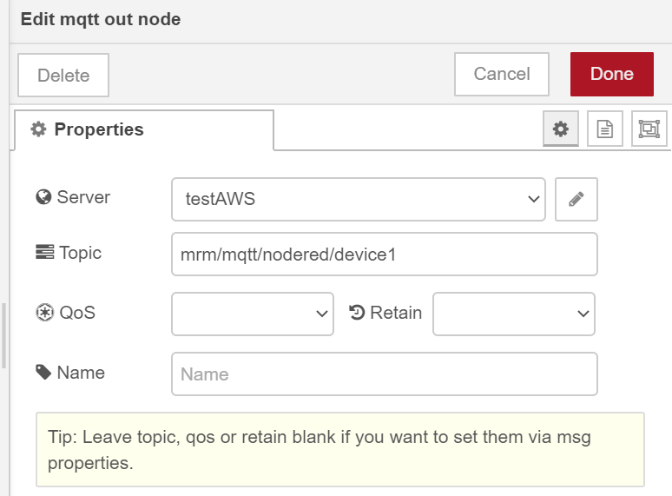

1. Attach the SSL/TLS certificate in the connector using the TLSv1.2 protocol as shown below.

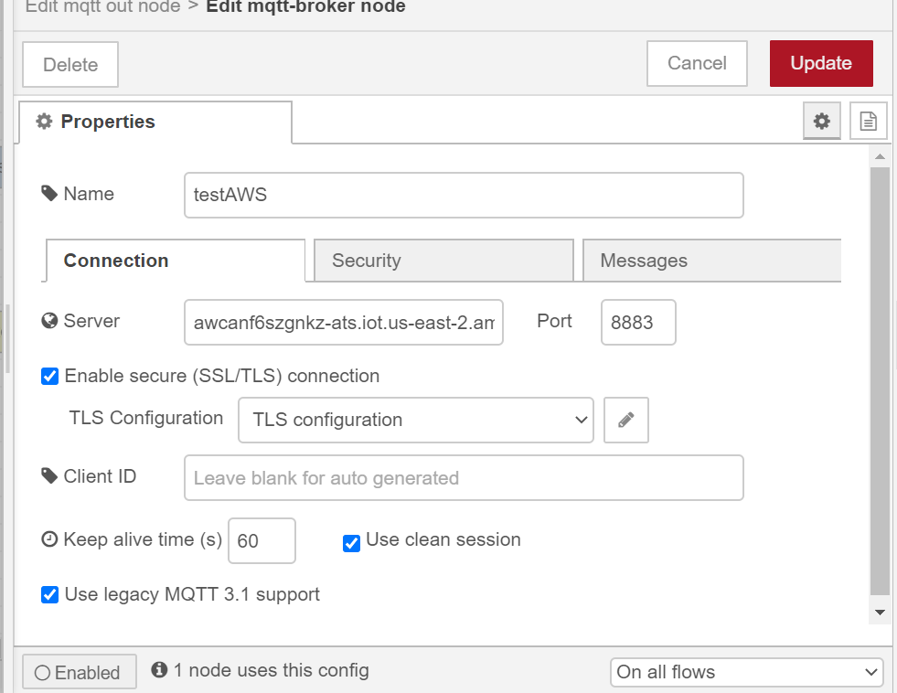

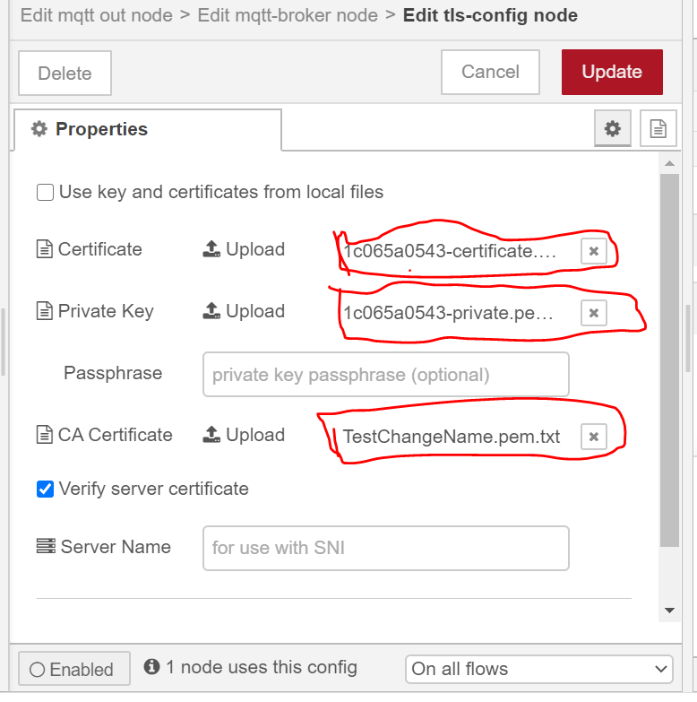

Note: TLSv1.2 and above is the supported TLS version from AWS, any lower version of TLS will not work.

1. Publish the topic “mrm/mqtt/nodered/device1” by hitting the url in the browser “https://<nodered-app-name>.eu-gb.mybluemix.net/topic1? power=12V&DeviceId=device1&DeviceName=Voltagesensor1” as shown in the below figure.

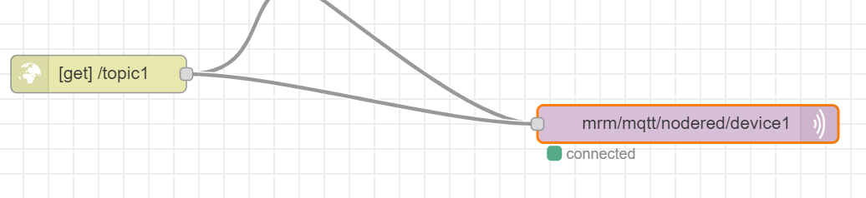

1. Tested the same, by subscribing to “mrm/mqtt/nodered/device1” in the MQTT client, the published messages will be displayed as shown in the below figure.

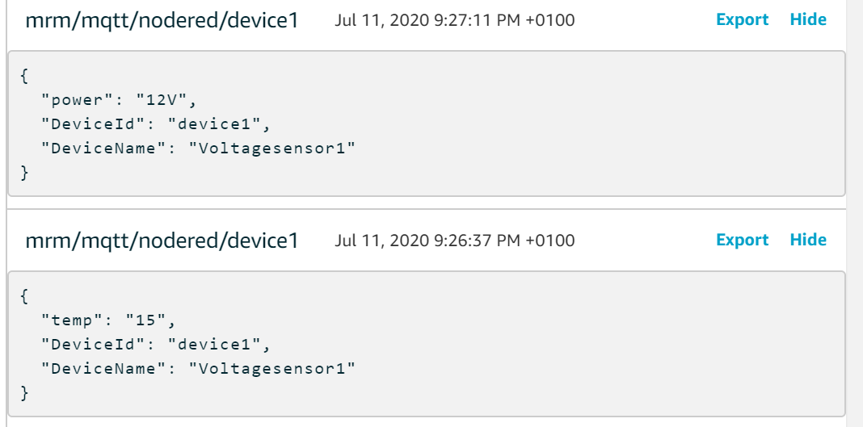

# Problems Faced

1. In this exercise, ensure the MQTT out must be displaying the status as connected after attaching the policy and TLS configuration. Kindly verify the below configuration.
   1. Each AWS account will have a different, verify the write URL and port.
   2. Ensure the Policy is attached to the certificate and verify both policies and certificates are activated.
   3. Correct TLS configuration must be set in the IBM node-red or else the connection between IBM node-red and AWS IoT core will not be connected.
2. Ensure the IBM Node-Red app is deployed if any changes in the flow diagram by clicking the “Deploy” button at the top, without deploying the app, changes will not be reflected.

# Conclusion

The purpose of the above exercise is to understand the basic mechanism of MQTT publish and subscribe to the topic for IBM node-red. By completing the above exercise will help to understand and simulate the experience on devices in the Industrial IoT world.

# References

[1] Node-Red, <https://nodered.org/>, 06-June-2020

[2] AWS IoT Core, <https://aws.amazon.com/iot-core/>, 01-June-2020.

[3] AWS IoT Policies, <https://docs.aws.amazon.com/iot/latest/developerguide/iot-policies.html?icmpid=docs_iot_console>, 06-June-2020.

[4] IBM Node-Red, <https://nodered.org/docs/platforms/bluemix>, 08-June-2020